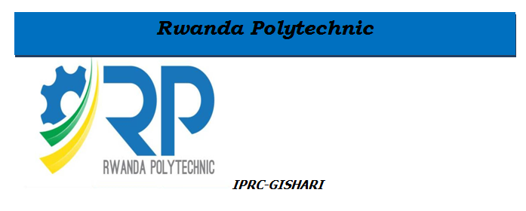

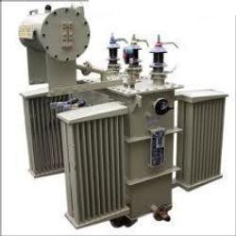

**MODULE TITLE: Power distribution and**

**electronics power Supply workshop**

**MODULE CODE: WET 102**

OBJECTIVES

Having successfully completed this part of the module, students should be able to:

1. Design the circuit of unregulated power supply and explain its operation
2. Explain the limitations of Unregulated Power Supply
3. Explain the need of a regulated Power supply in electronic circuits
4. Design the circuit of a regulated power supply and explain its operation
5. Distinguish the different types of IC voltage regulators
6. Differentiate a fixed voltage regulator from an adjustable one
7. Design a Zener diode voltage regulator
8. Explain the basic concepts pertinent to a single phase step down transformer
9. Explain the construction of a Single phase step down transformer and its operation

Table of Contents

OBJECTIVES 2

UNIT 1: Fabrication of DC regulated power supply 4

1.0 IDENTIFICATIONS OF PASSIVE COMPONENTS &ACTIVE COMPONENTS 4

PASSIVE COMPONENTS 4

ACTIVE COMPONENTS 4

FUNCTIONS GENERATORS 5

CATHODE-RAY OSCILLOSCOPE 6

MULTIMETER 6

What is a digital multimeter(DMM)? 6

What is an Analog Multimeter 8

1.1. Introduction to the voltage regulator 8

1.2. IC Voltage Regulators Classification 9

1.2.1. Fixed Voltage Regulators 9

1.2.2. Adjustable Voltage Regulator 10

1.2.3 Switching Regulators 12

1.3. Voltage regulation metrics 12

1.4. Power Supply Characteristics 13

1.5. Unregulated Power Supply 14

1.6. Regulated power supply 16

1.6.2. 15 volts Power Supply 21

1.6.3. Regulated Power Supply Applications 21

1.7. Zener Diode Voltage Regulator 22

UNIT II. SINGLE PHASE STEP DOWN TRANSFORMER WINDING 25

II.1. Transformer Basics 25

II.1.1. Introduction 25

II.1.2. Transformer Diagram (single-phase) 27

II.1.3. A Transformers Turns Ratio 28

II.1.4. Transformer Action 29

II.1.5. Electrical Power in a Transformer 32

II.1.6. Transformer Efficiency 34

II.1.7. Basic Representation of the Transformer 36

II.2.Transformer Construction 36

II.2.1. Introduction 36

II.2.2.Transformer Core Construction 37

II.2.3.Transformer Winding Arrangements 39

II.2.4.Transformer Dot Orientation 40

II.2.5.Transformer Core Losses 41

II.2.6. Copper Losses 43

II.3.Transformer Loading 43

II.4. Transformer Voltage Regulation 48

UNIT III: PCB DESIGN 49

III.1. INTRODUCTIONS 49

III.2. HOW TO CREATE A CIRCUIT BOARD 49

Starting with schematics 49

PCB design process 50

Preparing the board layout 50

## IDENTIFICATIONS OF PASSIVE COMPONENTS&ACTIVE COMPONENTS

### PASSIVE COMPONENTS

Firstly passive components are electronics components which cannot change the shape of signal,they have no feedback,and lately they are not even able to generate the signal themselves,

Example of the basics passive components are:resistor, capacitors and inductors

The properties and the clarifications of each components have been discussed in the previous class

### ACTIVE COMPONENTS

An active component is a device that has an analog electronic filter with the ability to amplify a signal or produce a power gain. There are two types of active components: electron tubes and semiconductors or solid-state devices. A typical active component would be an oscillator, transistor or integrated circuit.   
  
An active component works as an alternating-current circuit in a device, which works to increase the active power, voltage or current. An active component is able to do this because it is powered by a source of electricity that is separate from the electrical signal. the most example of active components as discussed in the previous lectures are diodes, transistors , thyristors, triac , somes ICS …….

Remember that the active and passive components have the contributions in the fabrications on the important electronics devices such as functions generators, oscilloscopes, multimeter, voltage regulators , power supply , ……….

### FUNCTIONS GENERATORS

A **function generator** is a usually a piece of electronic test equipment or software used to generate different types of electrical waveforms over a wide range of frequencies. Some of the most common waveforms produced by the **function generator** are the sine wave, square wave, triangular wave and saw tooth shapes.

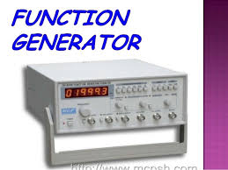

A **signal generator** is an electronic device that generates repeating or non-repeating electronic signals in either the analog or the digital domain. It is generally **used** in designing, testing, troubleshooting, and repairing electronic or electroacoustic devices, though it often has artistic **uses** as well.

### CATHODE-RAY OSCILLOSCOPE

**Cathode**-**ray oscilloscope**, electronic-display device containing a **cathode**-**ray** tube (CRT) that generates an electron beam that is used to produce visible patterns, or graphs, on a phosphorescent screen

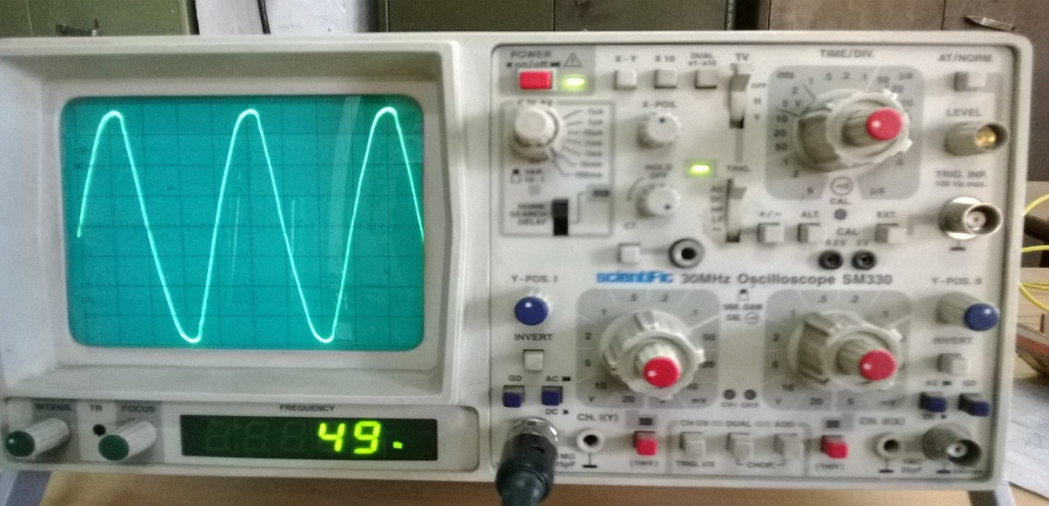

An **oscilloscope**, previously called an **oscillograph**, and informally known as a **scope** or **o-scope**, **CRO** (for cathode-ray oscilloscope), or **DSO** (for the more modern digital storage oscilloscope), is a type of [electronic test instrument](https://en.wikipedia.org/wiki/Electronic_test_instrument) that allows observation of varying signal [voltages](https://en.wikipedia.org/wiki/Voltage), usually as a two-dimensional plot of one or more signals as a function of time. Other signals (such as sound or vibration) can be converted to voltages and displayed.

Oscilloscopes are used to observe the change of an electrical signal over time, such that voltage and time describe a shape which is continuously graphed against a calibrated scale. The observed [waveform](https://en.wikipedia.org/wiki/Waveform) can be analyzed for such properties as [amplitude](https://en.wikipedia.org/wiki/Amplitude), [frequency](https://en.wikipedia.org/wiki/Frequency), [rise time](https://en.wikipedia.org/wiki/Rise_time), time interval, [distortion](https://en.wikipedia.org/wiki/Distortion) and others. Modern digital instruments may calculate and display these properties directly. Originally, calculation of these values required manually measuring the waveform against the scales built into the screen of the instrument.

### MULTIMETER

A multimeter or Volt-Ohm meter, is a device used to measure voltage, current and resistance. Multimeter might be analog type multimeteror digital multimeter*,* depending on the type of circuit being used.

### What is a digital multimeter****(DMM)****?

A **digital multimeter (DMM)** is a test tool used to measure two or more electrical values—principally voltage (volts), current (amps) and resistance (ohms). It is a standard diagnostic tool for technicians in the electrical/electronic industries.

Digital multimeters long ago replaced needle-based analog meters due to their ability to measure with greater accuracy, reliability and increased impedance. Fluke introduced its first digital multimeter in 1977.

Digital multimeters combine the testing capabilities of single-task meters—the voltmeter (for measuring volts), ammeter (amps) and ohmmeter (ohms). Often they include a number of additional specialized features or advanced options. Technicians with specific needs, therefore, can seek out a model targeted for particular tasks.

The face of a digital multimeter typically includes four components:

* Display: Where measurement readouts can be viewed.
* Buttons: For selecting various functions; the options vary by model.
* Dial (or rotary switch): For selecting primary measurement values (volts, amps, ohms).
* Input jacks: Where test leads are inserted.

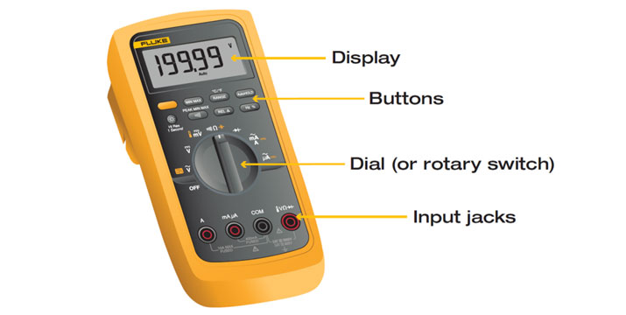

Test leads are flexible, insulated wires (red for positive, black for negative) that plug into the DMM. They serve as the conductor from the item being tested to the multimeter. The probe tips on each lead are used for testing circuits.

The terms counts and digits are used to describe a digital millimeter’s resolution—how fine a measurement a meter can make. By knowing a millimeter’s resolution, a technician can determine if it is possible to see a small change in a measured signal

### What is an [Analog Multimeter](https://www.electronics-notes.com/articles/test-methods/meters/analogue-multimeter.php)

A[analog](https://www.electronics-notes.com/articles/test-methods/meters/analogue-multimeter.php) or [analoguemultimeter](https://www.electronics-notes.com/articles/test-methods/meters/analogue-multimeter.php) is one of the trusty workhorses of the electronics test industry. [Analoguemultimeter](https://www.electronics-notes.com/articles/test-methods/meters/analogue-multimeter.php)s have been in use for very many years and sometimes go by the name VOA as a result of the fact that they measure [volts](https://www.electronics-notes.com/articles/test-methods/meters/analogue-multimeter.php), ohms and amps. These [multimeter](https://www.electronics-notes.com/articles/test-methods/meters/analogue-multimeter.php)s are extremely flexible and enable very many faults to be found in an electronic circuit.

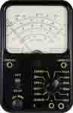

# 

# UNIT 1: Fabrication of DC regulated power supply

## 1.1. Introduction to the voltage regulator

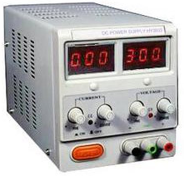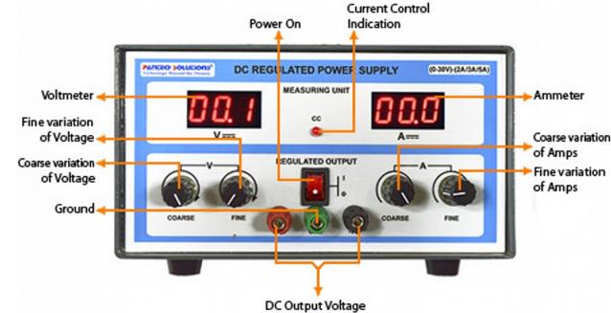

Voltage regulation is the process of holding a voltage steady under conditions of changing applied voltage and changing load current. Many electronic systems require a stable power supply voltage and use voltage regulators to accomplish that.

A voltage regulator is a voltage stabilizer that is designed to automatically stabilize a constant voltage level. A voltage regulator circuit is also used to change or stabilize the voltage level according to the necessity of the circuit. Thus, a voltage regulator is used for two reasons:-

1. To regulate or vary the output voltage of the circuit.
2. To keep the output voltage constant at the desired value in-spite of variations in the supply voltage or in the load current.

Voltage regulators find their applications in computers, alternators, power generator plants where the circuit is used to control the output of the plant.

A [**voltage regulator**](http://www.circuitstoday.com/voltage-regulators) is one of the most widely used electronic circuitry in any device. A regulated voltage (without fluctuations & noise levels) is very important for the smooth functioning of many digital electronic devices. A common case is with micro controllers, where a smooth regulated input voltage must be supplied for the micro controller to function smoothly.

## 1.2. IC Voltage Regulators Classification

Voltage regulators are of different types. In this article, our interest is only with IC based voltage regulator. An example of IC based voltage regulator available in market is the popular 7805 IC which regulates the output voltage at 5 volts. Now let’s come to the basic definition of an IC voltage regulator. It is an integrated circuit whose basic purpose is to regulate the unregulated input voltage (definitely over a predefined range) and provide with a constant, regulated output voltage**.**

An IC based voltage regulator can be classified in different ways. A common type of classification is 3 terminal voltage regulator and 5 or multi terminal voltage regulator. Another popular way of classifying IC voltage regulators is by identifying them as linear voltage regulator & switching voltage regulator.

There is a third set of classification as

1) Fixed voltage regulators (positive & negative)

2) Adjustable voltage regulators (positive & negative) and finally

3) Switching regulators.

In the third classification, fixed & adjustable regulators are basically versions of linear voltage regulators.

### ****1.2.1. Fixed Voltage Regulators****

These regulators provide a constant output voltage. A popular example is the 7805 IC which provides a constant 5 volts output**. A fixed voltage regulator can be a positive voltage regulator or a negative voltage regulator**. A positive voltage regulator provides with constant positive output voltage. All those IC’s in the 78XX series are fixed positive voltage regulators. In the IC nomenclature 78XX; the part XX denotes the regulated output voltage the IC is designed for. Examples: 7805, 7806, 7809 etc.

A negative fixed voltage regulator is same as the positive fixed voltage regulator in design, construction & operation. The only difference is in the polarity of output voltages. These IC’s are designed to provide a negative output voltage. Example: - 7905, 7906 and all those IC’s in the 79XX series.

## 1.2.2. Adjustable Voltage Regulator

An adjustable voltage regulator is a kind of regulator whose regulated output voltage can be varied over a range. There are two variations of the same; known as positive adjustable voltage regulator and negative adjustable regulator. LM317 is a classic example of positive adjustable voltage regulator, whose output voltage can be varied over a range of 1.2 volts to 57 volts. LM337 is an example of negative adjustable voltage regulator. LM337 is actually a complement of LM317 which are similar in operation & design; with the only difference being polarity of regulated output voltage.

There may be certain conditions where a variable voltage may be required. Right now we shall discuss how an LM317 adjustable positive voltage regulator IC is connected. The connection diagram is shown below.

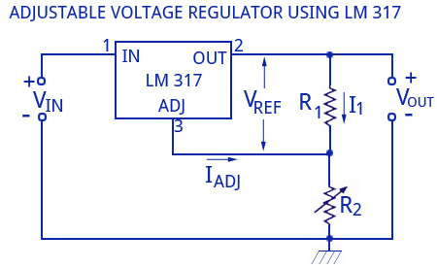

Figure1.1: Adjustable Voltage Regulator using LM317

The resistors R1 and R2 determine the output voltage Vout. The resistor R2 is adjusted to get the output voltage range between 1.2 volts to 57 volts. The output voltage that is required can be calculated using the equation:

Vout = Vref (1+R2/R1) + Iadj R2

In this circuit, the value of Vref is the reference voltage between the adjustment terminals and the output taken as 1.25 Volt.

The value of Iadj will be very small and will also have a constant value.  Thus the above equation can be rewritten as

Vout = 1.25 (1+R2/R1)

In the above equation, due to the small value of Iadj, the drop due to R2 is neglected.

The load regulation is 0.1 percent while the line regulation is 0.01 percent per volt. This means that theoutput voltage varies only 0.01 percent for each volt of input voltage. The ripple rejection is 80 db, equivalent to 10,000.

The LM 337 series of adjustable voltage regulators is a complement to the LM 317 series devices. The negative adjustable voltage regulators are available in the same voltage and current options as the LM 317 devices.

**Examples**

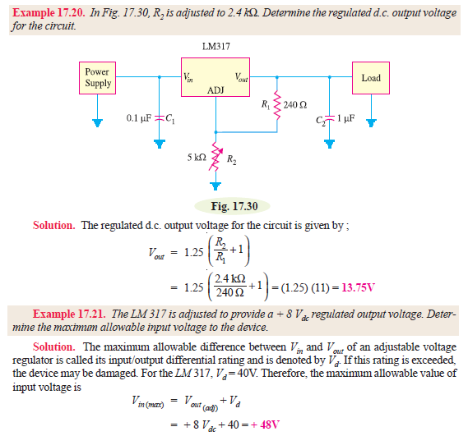

# 1.2.3Switching Regulators

Analog Devices offers a wide range of switching regulators that operate in step up (boost), step down (buck), and inverting modes. These devices are capable of generating a fixed or adjustable output voltage, and offer up to 2 A of output current. Some of the features available in ADI’s portfolio of switching regulators are low battery detector, user adjustable current limit, a variety of switching frequencies, and a reduced number of external components. This highly integrated, versatile family of products is intended to minimize external components for space challenged applications.

## 1.3. Voltage regulation metrics

The purpose of a voltage regulator is to maintain a constant voltage across a load regardless of variations in the applied input voltage and variations in the load current.

Two metrics, line regulation and load regulation, are used to quantify the performance of a voltage regulator.

**Line regulation**refers to the ability of the voltage regulator to reject variations in the applied voltage (often referred to as the line voltage because it is usually derived from the AC power line) and is expressed as a percentage. Ideally, the line regulation would be zero percent meaning that the output voltage is perfectly independent of the line voltage.

The equation for line regulation is as follows. Note that line voltage can also mean the DC input voltage for some applications. Line regulation always refers to whatever the input of interest is. Line regulation is expressed in percent and the ideal value is zero meaning that the output voltage is completely independent of the input voltage.



The nominal line voltage is typically the mid point between the highest and the lowest.

As an example an AC line operated power supply produces an output voltage of 12.13VDC when the AC line voltage is 125 VAC and an output voltage of 11.95 VDC when the AC line voltage is 115 VAC. The nominal or average output is (12.13 +11.95)/2 = 12.04. Using Equation above the line regulation is (12.13 – 11.95)/12.04 x 100% = 1.5%.

Good voltage regulators have a line regulation of well under one percent.

**Load regulation**refers to the ability of a voltage regulator to maintain a constant voltageas the load current varies and is expressed as a percentage. Ideally, the load regulationwould be zero percent meaning that the output voltage is perfectly independent of theload current. The equation for load regulation is as follows.

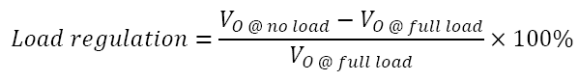

As an example the output of a voltage regulator is 5.04 volts at no load and 4.92 volts at full load. The load regulation is (5.04 – 4.92)/4.92 x 100% = 2.4%.

## 1.4. Power Supply Characteristics

**Quality of a power supply is determined by various characteristics like** load voltage, load current, voltage regulation, source regulation, output impedance, ripple rejection, and so on. Some of the characteristics are briefly explained below:

1. **Load Regulation** - The load regulation or load effect is the change in regulated output voltage when the load current changes from minimum to maximum value.

**Load regulation = Vno-load – Vfull-load**

 Vno-load – Load Voltage at no load

Vfull-load – Load voltage at full load.

From the above equation we can understand that when Vno-load occurs the load resistance is infinite, that is, the out terminals are open circuited. Vfull-load occurs when the load resistance is of the minimum value where voltage regulation is lost.

**% Load Regulation = [(Vno-load - Vfull-load)/Vfull-load] * 100**

2.**Minimum Load Resistance** - The load resistance at which a power supply delivers its full-load rated current at rated voltage is referred to as minimum load resistance.

**Minimum Load Resistance = Vfull-load/Ifull-load**

The value of Ifull-load, full load current should never increase than that mentioned in the data sheet of the power supply.

3. **Source/Line Regulation** - In the block diagram, the input line voltage has a nominal value of 230 Volts but in practice, there are considerable variations in ac supply mains voltage. Since this ac supply mains voltage is the input to the ordinary power supply, the filtered output of the bridge rectifier is almost directly proportional to the ac mains voltage.

The source regulation is defined as the change in regulated output voltage for a specified rage of line voltage.

4. **Output Impedance** - A regulated power supply is a very stiff dc voltage source. This means that the output resistance is very small. Even though the external load resistance is varied, almost no change is seen in the load voltage. An ideal voltage source has an output impedance of zero.

5. **Ripple Rejection** - Voltage regulators stabilize the output voltage against variations in input voltage. Ripple is equivalent to a periodic variation in the input voltage. Thus, a voltage regulator attenuates the ripple that comes in with the unregulated input voltage. Since a voltage regulator uses negative feedback, the distortion is reduced by the same factor as the gain.

## 1.5. Unregulated Power Supply

Almost all basic household electronic circuits need an unregulated AC to be converted to constant DC, in order to operate the electronic device. All devices will have a certain power supply limit and the electronic circuits inside these devices must be able to supply a constant DC voltage within this limit. That is, all the active and passive electronic devices will have a certain DC operating point (Q-point or Quiescent point), and this point must be achieved by the source of DC power. The DC power supply is practically converted to each and every stage in an electronic system. Thus a common requirement for all this phases will be the DC power supply. All low power system can be run with a battery. But, for long time operating devices, batteries could prove to be costly and complicated. The best method used is in the form of an unregulated power supply –a combination of a transformer, rectifier and a filter. The diagram is shown below.

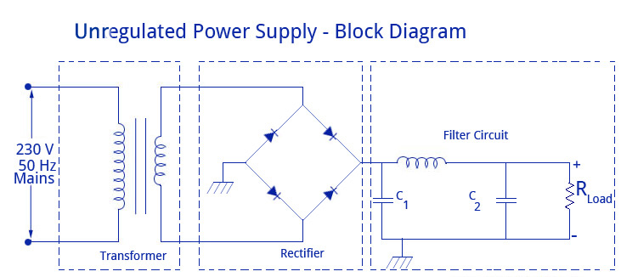

Unregulated Power Supply – Diagram

As shown in the figure above, a small step down transformer is used to reduce the voltage level to the devices needs. In India, a 1 Ø supply is available at 230 volts. The output of the transformer is a pulsating sinusoidal AC voltage, which is converted to pulsating DC with the help of a rectifier. This output is given to a filter circuit which reduces the AC ripples, and passes the DC components. But here are certain disadvantages in using an unregulated power supply.

**1. Poor Regulation -**When the load varies, the output does not appear constant. The output voltage changes by a great value due to the huge change in current drawn from the supply. This is mainly due to the high internal resistance of the power supply (>30 Ohms).

**2. AC Supply Main Variations -**The maximum variations in AC supply mains is give or take 6% of its rated value . But this value may go higher in some countries (180-280 volts). When the value is higher it’s DC voltage output will differ largely.

**3. Temperature Variation -**The use of semiconductor devices in electronic devices may cause variation in temperature.

These variations in dc output voltage may cause inaccurate or erratic operation or even malfunctioning of many electronic circuits. For instance, in oscillators the frequency will shift, in transmitters output will get distorted, and in amplifiers the operating point will shift causing bias instability.

All the above listed problems are overcome with the help of a [**voltage regulator**](http://www.circuitstoday.com/voltage-regulators) which is employed in conjunction with an unregulated power supply. Thus, the ripple voltage is largely reduced. Thus, the supply becomes a regulated power supply.

The internal circuitry of a regulated power supply also contains certain current limiting circuits which helps the supply circuit from getting fried from inadvertent circuits. Nowadays, all the power supplies use [**IC’s**](http://www.circuitstoday.com/integrated-circuits) to reduce ripples, enhance voltage regulation and for widened control options. Programmable power supplies are also available to allow remote operation that is useful in many settings.

## 1.6. Regulated power supply

Today almost every electronic device needs a dc supply for its smooth operation and they need to be operated within certain power supply limits. This required dc [voltage](http://www.electrical4u.com/voltage-or-electric-potential-difference/) or dc supply is derived from single phase ac mains. A **regulated power supply** can convert unregulated ac (alternating [current](http://www.electrical4u.com/electric-current-and-theory-of-electricity/) or voltage) to a constant dc (direct [current](http://www.electrical4u.com/electric-current-and-theory-of-electricity/) or voltage). A **regulated power supply** is used to ensure that the output remains constant even if the input changes. A regulated DC power supply is also called as a linear power supply, it is an embedded circuit and consists of various blocks. The regulated power supply will accept an ac input and give a constant dc output. Figure below shows the block diagram of a typical regulated dc power supply.

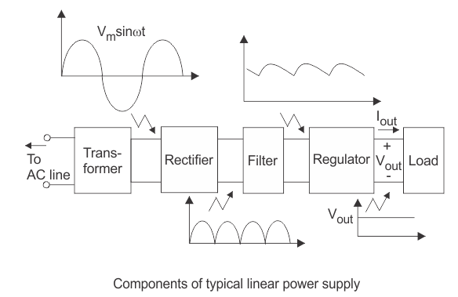

The basic building blocks of a regulated dc power supply are as follows:

1. A step down transformer 2. A rectifier 3. A DC filter 4. A regulator

**Operation of Regulated Power Supply**

**Step Down Transformer**

A step down transformer will step down the [voltage](http://www.electrical4u.com/voltage-or-electric-potential-difference/) from the ac mains to the required [voltage](http://www.electrical4u.com/voltage-or-electric-potential-difference/) level. The turn’s ratio of the transformer is so adjusted such as to obtain the required [voltage](http://www.electrical4u.com/voltage-or-electric-potential-difference/) value. The output of the transformer is given as an input to the rectifier circuit.

**Rectification**

Rectifier is an electronic circuit consisting of diodes which carries out the rectification process. Rectification is the process of converting an alternating [voltage](http://www.electrical4u.com/voltage-or-electric-potential-difference/) or [current](http://www.electrical4u.com/electric-current-and-theory-of-electricity/) into corresponding direct (dc) quantity. The input to a rectifier is ac whereas its output is unidirectional pulsating dc. Usually a full wave rectifier or a bridge rectifier is used to rectify both the half cycles of the ac supply (full wave rectification). Figure below shows a [full wave bridge rectifier](http://www.electrical4u.com/full-wave-diode-rectifier/).

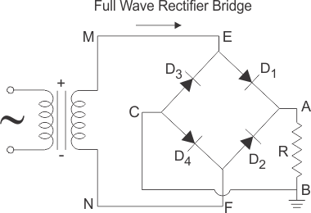

A bridge rectifier consists of four p-n junction diodes connected in the above shown manner. In the positive half cycle of the supply the [voltage](http://www.electrical4u.com/voltage-or-electric-potential-difference/) induced across the secondary of the [electrical transformer](http://www.electrical4u.com/what-is-transformer-definition-working-principle-of-transformer/) i.e. VMN is positive. Therefore point E is positive with respect to F. Hence, diodes D3 and D2 are reversed biased and diodes D1 and D4 are forward biased. The [diode](http://www.electrical4u.com/diode-working-principle-and-types-of-diode/) D3 and D2 will act as open switches (practically there is some [voltage](http://www.electrical4u.com/voltage-or-electric-potential-difference/) drop) and diodes D1 andD4 will act as closed switches and will start conducting. Hence a rectified waveform appears at the output of the rectifier as shown in the first figure. When [voltage](http://www.electrical4u.com/voltage-or-electric-potential-difference/) induced in secondary i.e. VMN is negative than D3 and D2 are forward biased with the other two reversed biased and a positive [voltage](http://www.electrical4u.com/voltage-or-electric-potential-difference/) appears at the input of the filter.

**DC Filtration**

The rectified [voltage](http://www.electrical4u.com/voltage-or-electric-potential-difference/) from the rectifier is a pulsating dc [voltage](http://www.electrical4u.com/voltage-or-electric-potential-difference/) having very high ripple content. But this is not we want, we want a pure ripple free dc waveform. Hence a filter is used. Different types of filters are used such as [capacitor](http://www.electrical4u.com/what-is-capacitor-and-what-is-dielectric/) filter, LC filter, Choke input filter, π type filter. Figure below shows a [capacitor](http://www.electrical4u.com/what-is-capacitor-and-what-is-dielectric/) filter connected along the output of the rectifier and the resultant output waveform.

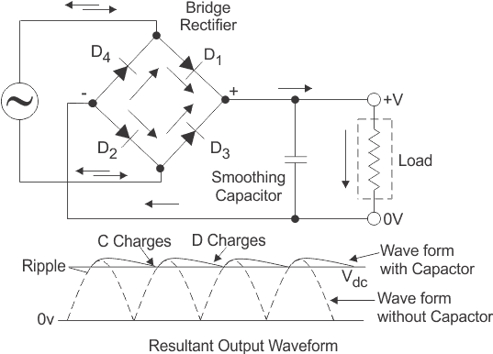

As the instantaneous [voltage](http://www.electrical4u.com/voltage-or-electric-potential-difference/) starts increasing the [capacitor](http://www.electrical4u.com/what-is-capacitor-and-what-is-dielectric/) charges, it charges till the waveform reaches its peak value. When the instantaneous value starts reducing the [capacitor](http://www.electrical4u.com/what-is-capacitor-and-what-is-dielectric/) starts discharging exponentially and slowly through the load (input of the regulator in this case). Hence, an almost constant dc value having very less ripple content is obtained.

**Regulation**

This is the last block in a regulated DC power supply. The output [voltage](http://www.electrical4u.com/voltage-or-electric-potential-difference/) or [current](http://www.electrical4u.com/electric-current-and-theory-of-electricity/) will change or fluctuate when there is change in the input from ac mains or due to change in load current at the output of the regulated power supply or due to other factors like temperature changes. This problem can be eliminated by using a regulator. A regulator will maintain the output constant even when changes at the input or any other changes occur.

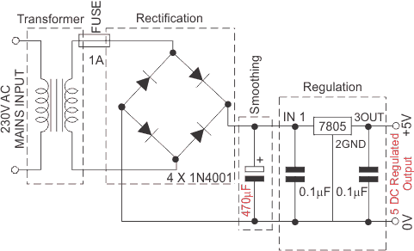

**Summary**

There are many types of power supply. Most are designed to convert high voltage AC mains electricity to a suitable low voltage supply for electronic circuits and other devices. A power supply can by broken down into a series of blocks, each of which performs a particular function.

For example a 5V regulated supply:

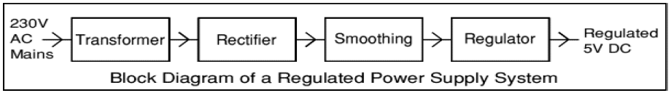

Each of the blocks is described in more detail below:

• **Transformer** - steps down high voltage AC mains to low voltage AC.

• **Rectifier** - converts AC to DC, but the DC outpu t is varying.

• **Smoothing** - smoothes the DC from varying greatly to a small ripple.

• **Regulator** - eliminates ripple by setting DC output to a fixed voltage.

### 1.6.2. 15 volts Power Supply

[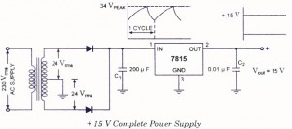](http://www.circuitstoday.com/wp-content/uploads/2009/10/15-volt-power-supply.jpg)

15 volt power supply

The series 7800 regulators provide eight voltage options, ranging from 5 to 24 V. These ICs are designed as fixed voltage regulators and with adequate heat sinking can deliver output currents in excess of 1 A. Although these devices do not require any external component, such components can be employed for providing adjustable voltages and currents. These ICs also have internal thermal overload protection and internal short-circuit current limiting. Figure illustrates how one such IC, a 7815, is connected to provide voltage regulation with output of + 15 V dc from this unit. An unregulated, input voltage Vin is filtered by capacitor C, and connected to the pin .1 (IN terminal) of IC. The pin 2 (OUT terminal) of the IC provides a regulated + 15 V which is filtered by capacitor C2 (mostly for any high frequency noise). The third pin (GND terminal) of the IC is connected to ground. While the input voltage may vary over some permissible voltage range, and the output load may vary over some acceptable range, the output voltage remains constant within specified voltage variation limits. These limitations are mentioned in the manufacturer’s specification sheet. In addition, the difference between input and output voltages (Vin- Vout), called the dropout voltage, must be typically 20 V, even during the low point on the input ripple voltage. Furthermore, the  capacitor  C1, is required if the regulator is located an appreciable distance from a power supply filter. Even though C2 is not required, it may be used to improve the transient response of the regulator.

### 1.6.3. Regulated Power Supply Applications

* D.C. variable bench supply (a **bench power supply** usually refers to a [power supply](https://en.wikipedia.org/wiki/Power_supply) capable of supplying a variety of output voltages useful for [bench testing](https://en.wikipedia.org/w/index.php?title=Bench_testing&action=edit&redlink=1) electronic circuits, possibly with continuous variation of the output voltage, or just some preset voltages; a laboratory (lab) power supply normally implies an accurate bench power supply, while a balanced or tracking power supply refers to twin supplies for use when a circuit requires both positive and negative supply rails).
* Mobile Phone power adaptors
* Regulated power supplies in appliances
* Various amplifiers and oscillators

## 1.7. Zener Diode Voltage Regulator



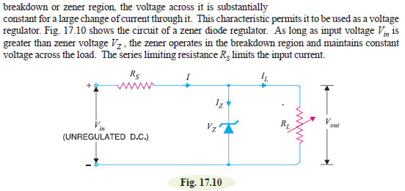

OPERATIONS: the zener will maintain constant voltage across the load inspite of changes in load current or input voltage. As the load current increases, the zener current decreases so that current through resistance Rs is constant. As output voltage =Vin – IRs and I is constant, therefore, output voltage remains unchanged. The reverse would be true should the current decrease. The circuit will also correct fore the changes in input voltages. Should the input voltage Vin increase, more current will flow through the zener, the voltage drop across Rs will increase but load voltage would would remain constant. The reverse would be true should the input voltage decrease.

LIMITATIONS. A zener diode regulator has the following drawbacks

1. It has low efficiency for heavy load currents. It is because if the load current is large, there will be considerable power loss in the series limiting resistance
2. The output voltage slightly changes due to zener impedances as Vout =Vz+IzZz. Changes I n load current produce changes in zener current. Consequently, the output voltage also changes. Therefore , the use of this circuits is limited to only such applications where variations in load current and input voltage

**Conditions for proper operation of Zener regulator**

# 

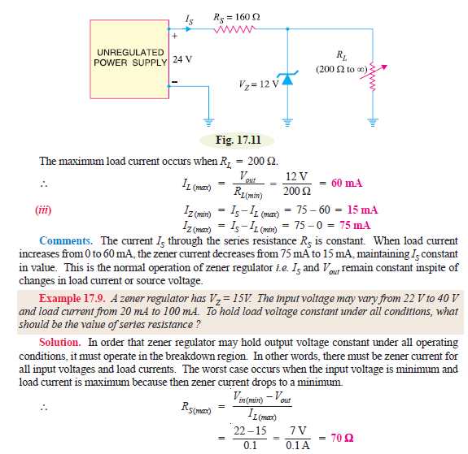

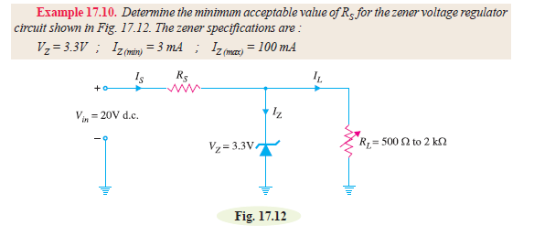

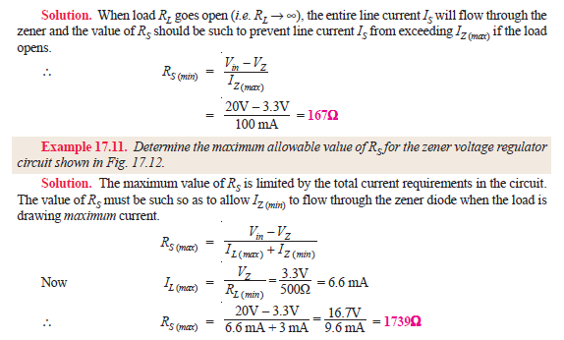

# UNIT II.SINGLE PHASE STEP DOWN TRANSFORMER WINDING

## II.1. Transformer Basics

### II.1.1. Introduction

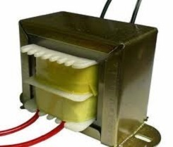

**1. Introduction**

**Atransformer is adevice that transfer**[**s electrical energy f**](http://en.wikipedia.org/wiki/Electrical_energy)**rom one** [**circuit to**](http://en.wikipedia.org/wiki/Electrical_network) **another through** [**inductively coupled c**](http://en.wikipedia.org/wiki/Inductive_coupling)**onductors—the transformer'scoils**.Avarying [current or](http://en.wikipedia.org/wiki/Electric_current) an **a.c induces emf1** in the first or *primary* winding with n1 turns which creates avarying [magnetic](http://en.wikipedia.org/wiki/Magnetic_flux) [flux in](http://en.wikipedia.org/wiki/Magnetic_flux) the transformer'score and thus a varying [magnetic field thro](http://en.wikipedia.org/wiki/Magnetic_field)ugh the *secondary* winding. This varying magnetic field [induces a](http://en.wikipedia.org/wiki/Electromagnetic_induction) varying [electromotive force (EMF),](http://en.wikipedia.org/wiki/Electromotive_force)or"[voltage"](http://en.wikipedia.org/wiki/Volt),in the secondary winding. This **effect is called** [**mutual induction.**](http://en.wikipedia.org/wiki/Mutual_induction)

Losses in transformers are generally low and thus efficiency is high. Being static they have a long life and are very stable.

Transformers range in size from the miniature units used in electronic applications to the large power transformers used in power stations. The principle of operation is the same for each.

A transformer is represented in **figure (a)** below as consisting of two electrical circuits linked by a common ferromagnetic core. One coil is termed the primary winding which is connected to the supply of electricity, and the other the secondary winding, which may be connected to a load. A circuit diagram symbol for a transformer is shown in **figure(b)**

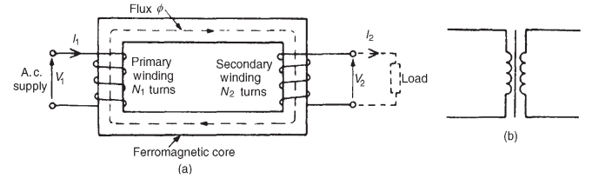

The **Voltage Transformer** can be thought of as an electrical component rather than an electronic component. A transformer basically is very simple static (or stationary) electro-magnetic passive electrical device that works on the principle of Faraday’s law of induction by converting electrical energy from one value to another.

The transformer does this by linking together two or more electrical circuits using a common oscillating magnetic circuit which is produced by the transformer itself. A transformer operates on the principals of “electromagnetic induction”, in the form of  [**Mutual Induction**](http://www.electronics-tutorials.ws/inductor/mutual-inductance.html).

Mutual induction is the process by which a coil of wire magnetically induces a voltage into another coil located in close proximity to it. Then we can say that transformers work in the “magnetic domain”, and transformers get their name from the fact that they “transform” one voltage or current level into another.

Transformers are capable of either increasing or decreasing the voltage and current levels of their supply, without modifying its frequency, or the amount of electrical power being transferred from one winding to another via the magnetic circuit.

A single phase voltage transformer basically consists of two electrical coils of wire, one called the “Primary Winding” and another called the “Secondary Winding”. For this tutorial we will define the “primary” side of the transformer as the side that usually takes power, and the “secondary” as the side that usually delivers power. In a single-phase voltage transformer the primary is usually the side with the higher voltage.

These two coils are not in electrical contact with each other but are instead wrapped together around a common closed magnetic iron circuit called the “core”. This soft iron core is not solid but made up of individual laminations connected together to help reduce the core’s losses.

The two coil windings are electrically isolated from each other but are magnetically linked through the common core allowing electrical power to be transferred from one coil to the other. When an electric current passed through the primary winding, a magnetic field is developed which induces a voltage into the secondary winding as shown.

**Single Phase Voltage Transformer**

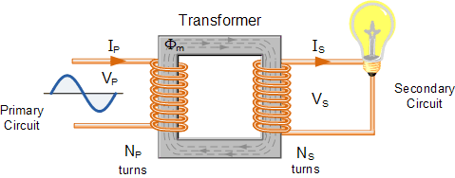

In other words, for a transformer there is no direct electrical connection between the two coil windings, thereby giving it the name also of an **Isolation Transformer**. Generally, the primary winding of a transformer is connected to the input voltage supply and converts or transforms the electrical power into a magnetic field. While the job of the secondary winding is to convert this alternating magnetic field into electrical power producing the required output voltage as shown.

### I I.1.2. Transformer Diagram (single-phase)

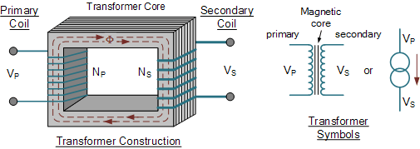

* Where:
* VP  -  is the Primary Voltage
* VS  -  is the Secondary Voltage
* NP  -  is the Number of Primary Windings
* NS  -  is the Number of Secondary Windings
* Φ (phi)  -  is the Flux Linkage

Notice that the two coil windings are not electrically connected but are only linked magnetically. A single-phase transformer can operate to either increase or decrease the voltage applied to the primary winding. When a transformer is used to “increase” the voltage on its secondary winding with respect to the primary, it is called a **Step-up transformer**. When it is used to “decrease” the voltage on the secondary winding with respect to the primary it is called a **Step-down transformer**.

However, a third condition exists in which a transformer produces the same voltage on its secondary as is applied to its primary winding. In other words, its output is identical with respect to voltage, current and power transferred. This type of transformer is called an “Impedance Transformer” and is mainly used for impedance matching or the isolation of adjoining electrical circuits.

The difference in voltage between the primary and the secondary windings is achieved by changing the number of coil turns in the primary winding ( NP ) compared to the number of coil turns on the secondary winding ( NS ).

As the transformer is basically a linear device, a ratio now exists between the number of turns of the primary coil divided by the number of turns of the secondary coil. This ratio, called the ratio of transformation, more commonly known as a transformers “turns ratio”, ( TR ). This turns ratio value dictates the operation of the transformer and the corresponding voltage available on the secondary winding.

It is necessary to know the ratio of the number of turns of wire on the primary winding compared to the secondary winding. The turns ratio, which has no units, compares the two windings in order and is written with a colon, such as 3:1 (3-to-1). This means in this example, that if there are 3 volts on the primary winding there will be 1 volt on the secondary winding, 3 volts-to-1 volt. Then we can see that if the ratio between the number of turns changes the resulting voltages must also change by the same ratio, and this is true.

Transformers are all about “ratios”. The ratio of the primary to the secondary, the ratio of the input to the output, and the turns ratio of any given transformer will be the same as its voltage ratio. In other words for a transformer: “turns ratio = voltage ratio”. The actual number of turns of wire on any winding is generally not important, just the turns ratio and this relationship is given as:

### II.1.3. A Transformers Turns Ratio

transformer turns ratio equation

Assuming an ideal transformer and the phase angles:  ΦP ≡ ΦS

Note that the order of the numbers when expressing a transformers turns ratio value is very important as the turns ratio 3:1 expresses a very different transformer relationship and output voltage than one in which the turns ratio is given as: 1:3.

**Transformer Basics Example No1**

A voltage transformer has 1500 turns of wire on its primary coil and 500 turns of wire for its secondary coil. What will be the turns ratio (TR) of the transformer.

transformer turns ratio

This ratio of 3:1 (3-to-1) simply means that there are three primary windings for every one secondary winding. As the ratio moves from a larger number on the left to a smaller number on the right, the primary voltage is therefore stepped down in value as shown.

**Transformer Basics Example No2**

If 240 volts rms is applied to the primary winding of the same transformer above, what will be the resulting secondary no load voltage.

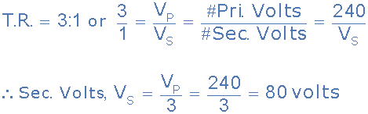

Again confirming that the transformer is a “step-down” transformer as the primary voltage is 240 volts and the corresponding secondary voltage is lower at 80 volts.

Then the main purpose of a transformer is to transform voltages at preset ratios and we can see that the primary winding has a set amount or number of windings (coils of wire) on it to suit the input voltage. If the secondary output voltage is to be the same value as the input voltage on the primary winding, then the same number of coil turns must be wound onto the secondary core as there are on the primary core giving an even turns ratio of 1:1 (1-to-1). In other words, one coil turn on the secondary to one coil turn on the primary.

If the output secondary voltage is to be greater or higher than the input voltage, (step-up transformer) then there must be more turns on the secondary giving a turns ratio of 1:N (1-to-N), where N represents the turns ratio number. Likewise, if it is required that the secondary voltage is to be lower or less than the primary, (step-down transformer) then the number of secondary windings must be less giving a turns ratio of N:1 (N-to-1).

### II.1.4. Transformer Action

We have seen that the number of coil turns on the secondary winding compared to the primary winding, the turns ratio, affects the amount of voltage available from the secondary coil. But if the two windings are electrically isolated from each other, how is this secondary voltage produced?

We have said previously that a transformer basically consists of two coils wound around a common soft iron core. When an alternating voltage ( VP ) is applied to the primary coil, current flows through the coil which in turn sets up a magnetic field around itself, called mutual inductance, by this current flow according to *Faraday’s Law* of electromagnetic induction. The strength of the magnetic field builds up as the current flow rises from zero to its maximum value which is given as dΦ/dt.

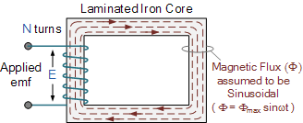

As the magnetic lines of force setup by this electromagnet expand outward from the coil the soft iron core forms a path for and concentrates the magnetic flux. This magnetic flux links the turns of both windings as it increases and decreases in opposite directions under the influence of the AC supply.

However, the strength of the magnetic field induced into the soft iron core depends upon the amount of current and the number of turns in the winding. When current is reduced, the magnetic field strength reduces.

When the magnetic lines of flux flow around the core, they pass through the turns of the secondary winding, causing a voltage to be induced into the secondary coil. The amount of voltage induced will be determined by: N.dΦ/dt (Faraday’s Law), where N is the number of coil turns. Also this induced voltage has the same frequency as the primary winding voltage.

Then we can see that the same voltage is induced in each coil turn of both windings because the same magnetic flux links the turns of both the windings together. As a result, the total induced voltage in each winding is directly proportional to the number of turns in that winding. However, the peak amplitude of the output voltage available on the secondary winding will be reduced if the magnetic losses of the core are high.

If we want the primary coil to produce a stronger magnetic field to overcome the cores magnetic losses, we can either send a larger current through the coil, or keep the same current flowing, and instead increase the number of coil turns ( NP ) of the winding. The product of amperes times turns is called the “ampere-turns”, which determines the magnetising force of the coil.

So assuming we have a transformer with a single turn in the primary, and only one turn in the secondary. If one volt is applied to the one turn of the primary coil, assuming no losses, enough current must flow and enough magnetic flux generated to induce one volt in the single turn of the secondary. That is, each winding supports the same number of volts per turn.

As the magnetic flux varies sinusoidally, Φ = Φmax sinωt, then the basic relationship between induced emf, (E) in a coil winding of N turns is given by:

**emf = turns x rate of change**

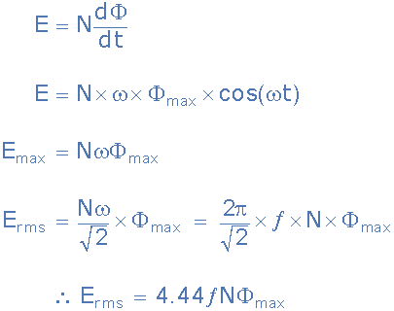

Where:

* ƒ  -  is the flux frequency in Hertz,  = ω/2π
* Ν  -  is the number of coil windings.
* Φ  -  is the flux density in webers

This is known as the **Transformer EMF Equation**. For the primary winding emf, N will be the number of primary turns, ( NP ) and for the secondary winding emf, N will be the number of secondary turns, ( NS ).

Also please note that as transformers require an alternating magnetic flux to operate correctly, transformers cannot therefore be used to transform or supply DC voltages or currents, since the magnetic field must be changing to induce a voltage in the secondary winding. In other words, **transformers DO NOT operate on steady state DC voltages**, only alternating or pulsating voltages.

If a transformer’s primary winding was connected to a DC supply, the inductive reactance of the winding would be zero as DC has no frequency, so the effective impedance of the winding will therefore be very low and equal only to the resistance of the copper used. Thus the winding will draw a very high current from the DC supply causing it to overheat and eventually burn out, because as we know I = V/R.

**Transformer Basics Example No.3**

A single phase transformer has 480 turns on the primary winding and 90 turns on the secondary winding. The maximum value of the magnetic flux density is 1.1T when 2200 volts, 50Hz is applied to the transformer primary winding. Calculate:

a). The maximum flux in the core.

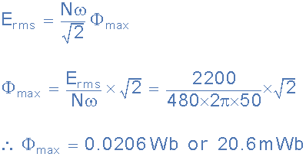

b)The cross-sectional area of the core.

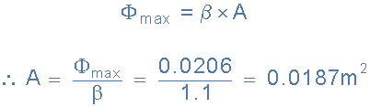

c). The secondary induced emf.

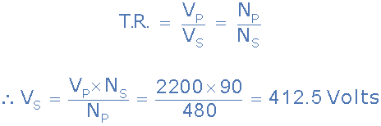

### II.1.5. Electrical Power in a Transformer

Another one of the transformer basic parameters is its power rating. The power rating of a transformer is obtained by simply multiplying the current by the voltage to obtain a rating in **Volt-amperes**, ( VA ). Small single phase transformers may be rated in volt-amperes only, but much larger power transformers are rated in units of **Kilo volt-amperes**, ( kVA ) where 1 kilo volt-ampere is equal to 1,000 volt-amperes, and units of **Mega volt-amperes**, ( MVA ) where 1 mega volt-ampere is equal to 1 million volt-amperes.

In an ideal transformer (ignoring any losses), the power available in the secondary winding will be the same as the power in the primary winding, they are constant wattage devices and do not change the power only the voltage to current ratio. Thus, in an ideal transformer the **Power Ratio** is equal to one (unity) as the voltage, V multiplied by the current, I will remain constant.

That is the electric power at one voltage/current level on the primary is “transformed” into electric power, at the same frequency, to the same voltage/current level on the secondary side. Although the transformer can step-up (or step-down) voltage, it cannot step-up power. Thus, when a transformer steps-up a voltage, it steps-down the current and vice-versa, so that the output power is always at the same value as the input power. Then we can say that primary power equals secondary power, ( PP = PS ).

**Power in a Transformer**

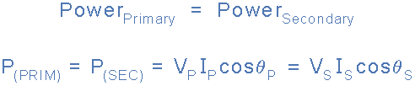

Where: ΦP is the primary phase angle and ΦS is the secondary phase angle.

Note that since power loss is proportional to the square of the current being transmitted, that is: I2R, increasing the voltage, let’s say doubling ( ×2 ) the voltage would decrease the current by the same amount, ( ÷2 ) while delivering the same amount of power to the load and therefore reducing losses by factor of 4. If the voltage was increased by a factor of 10, the current would decrease by the same factor reducing overall losses by factor of 100.

**Transformer Basics – Efficiency**

A transformer does not require any moving parts to transfer energy. This means that there are no friction or windage losses associated with other electrical machines. However, transformers do suffer from other types of losses called “copper losses” and “iron losses” but generally these are quite small.

Copper losses, also known as I2R loss is the electrical power which is lost in heat as a result of circulating the currents around the transformers copper windings, hence the name. Copper losses represents the greatest loss in the operation of a transformer. The actual watts of power lost can be determined (in each winding) by squaring the amperes and multiplying by the resistance in ohms of the winding (I2R).

Iron losses, also known as hysteresis is the lagging of the magnetic molecules within the core, in response to the alternating magnetic flux. This lagging (or out-of-phase) condition is due to the fact that it requires power to reverse magnetic molecules; they do not reverse until the flux has attained sufficient force to reverse them.

Their reversal results in friction, and friction produces heat in the core which is a form of power loss. Hysteresis within the transformer can be reduced by making the core from special steel alloys.

The intensity of power loss in a transformer determines its efficiency. The efficiency of a transformer is reflected in power (wattage) loss between the primary (input) and secondary (output) windings. Then the resulting efficiency of a transformer is equal to the ratio of the power output of the secondary winding, PS to the power input of the primary winding, PP and is therefore high.

An ideal transformer is 100% efficient because it delivers all the energy it receives. Real transformers on the other hand are not 100% efficient and at full load, the efficiency of a transformer is between 94% to 96% which is quiet good. For a transformer operating with a constant voltage and frequency with a very high capacity, the efficiency may be as high as 98%. The efficiency, η of a transformer is given as:

### II.1.6. Transformer Efficiency

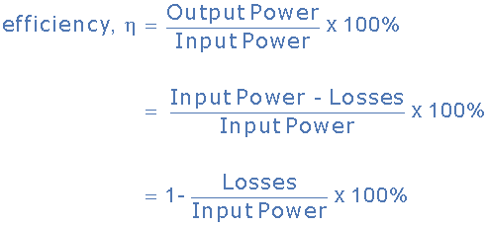

Where: Input, Output and Losses are all expressed in units of power.

Generally when dealing with transformers, the primary watts are called “volt-amps”, **VA** to differentiate them from the secondary watts. Then the efficiency equation above can be modified to:

transformer basics - efficiency

It is sometimes easier to remember the relationship between the transformers input, output and efficiency by using pictures. Here the three quantities of VA, W and η have been superimposed into a triangle giving power in watts at the top with volt-amps and efficiency at the bottom. This arrangement represents the actual position of each quantity in the efficiency formulas.

**Transformer Efficiency Triangle**

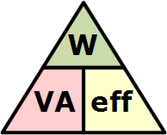

transposing the above triangle quantities gives us the following combinations of the same equation:

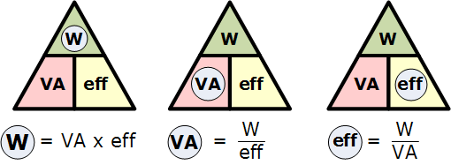

Then, to find Watts (output) = VA x eff., or to find VA (input) = W/eff., or to find Efficiency, eff. = W/VA, etc.

**Transformer Basics Summary**

Then to summarize, A **Transformer** changes the voltage level (or current level) on its input winding to another value on its output winding using a magnetic field. A transformer consists of two electrically isolated coils and operates on Faraday’s principal of “mutual induction”, in which an EMF is induced in the transformers secondary coil by the magnetic flux generated by the voltages and currents flowing in the primary coil winding.

Both the primary and secondary coil windings are wrapped around a common soft iron core made of individual laminations to reduce eddy current and power losses. The primary winding of th e transformer is connected to the AC power source which must be sinusoidal in nature, while the secondary winding supplies power to the load.

We can represent the transformer in block diagram form as follows:

### II.1.7. Basic Representation of the Transformer

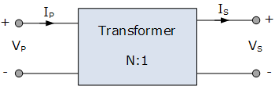

The ratio of the transformers primary and secondary windings with respect to each other produces either a step-up voltage transformer or a step-down voltage transformer with the ratio between the number of primary turns to the number of secondary turns being called the “turns ratio” or “transformer ratio”.

If this ratio is less than unity, n < 1 then NS is greater than NP and the transformer is classed as a step-up transformer. If this ratio is greater than unity, n > 1, that is NP is greater than NS, the transformer is classed as a step-down transformer. Note that single phase step-down transformer can also be used as a step-up transformer simply by reversing its connections and making the low voltage winding its primary, and vice versa as long as the transformer is operated within its original VA design rating.

If the turns ratio is equal to unity, n = 1 then both the primary and secondary have the same number of windings, therefore the voltages and currents are the same for both windings.

This type of transformer is classed as an isolation transformer as both the primary and secondary windings of the transformer have the same number of volts per turn. The efficiency of a transformer is the ratio of the power it delivers to the load to the power it absorbs from the supply. In an ideal transformer there are no losses so no loss of power then Pin = Pout.

## II.2.Transformer Construction

### II.2.1. Introduction

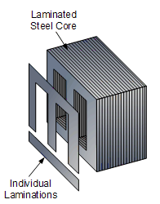

The construction of a simple two-winding transformer consists of each winding being wound on a separate limb or core of the soft iron form which provides the necessary magnetic circuit.

This magnetic circuit, know more commonly as the “transformer core” is designed to provide a path for the magnetic field to flow around, which is necessary for induction of the voltage between the two windings.

However, this type of **transformer construction** where the two windings are wound on separate limbs is not very efficient since the primary and secondary windings are well separated from each other. This results in a low magnetic coupling between the two windings as well as large amounts of magnetic flux leakage from the transformer itself. But as well as the “O” shapes construction, there are different types of “transformer construction” and designs available which are used to overcome these inefficiencies producing a smaller more compact transformer.

The efficiency of a simple transformer construction can be improved by bringing the two windings within close contact with each other thereby improving the magnetic coupling. Increasing and concentrating the magnetic circuit around the coils may improve the magnetic coupling between the two windings, but it also has the effect of increasing the magnetic losses of the transformer core as well as providing a low reluctance path for the magnetic field.

The core is designed to prevent circulating electric currents within the iron core itself. Circulating currents, called “eddy currents”, cause heating and energy losses within the core decreasing the transformers efficiency.

These losses are due mainly to voltages induced in the iron circuit, which is constantly being subjected to the alternating magnetic fields setup by the external sinusoidal supply voltage. One way to reduce these unwanted power losses is to construct the transformer core from thin steel laminations.

In all types of transformer construction, the central iron core is constructed from of a highly permeable material made from thin silicon steel laminations assembled together to provide the required magnetic path with the minimum of losses. The resistivity of the steel sheet itself is high, reducing the eddy current losses is achieved by making the laminations very thin.

These steel transformer laminations vary in thickness’s from between 0.25mm to 0.5mm and as steel is a conductor, the laminations are electrically insulated from each other by a very thin coating of insulating varnish or by the use of an oxide layer on the surface.

### II.2.2.Transformer Core Construction

Generally, the name associated with the construction of a transformer is dependent upon how the primary and secondary windings are wound around the central laminated steel core. The two most common and basic designs of transformer construction are the **Closed-core Transformer** and the **Shell-core Transformer**.

In the “closed-core” type (core form) transformer, the primary and secondary windings are wound outside and surround the core ring. In the “shell type” (shell form) transformer, the primary and secondary windings pass inside the steel magnetic circuit (core) which forms a shell around the windings as shown below.

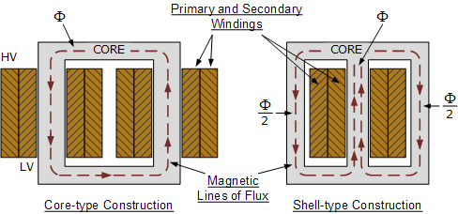

In both types of transformer core design, the magnetic flux linking the primary and secondary windings travels entirely within the core with no loss of magnetic flux through air. In the core type transformer construction, one half of each winding is wrapped around each leg (or limb) of the transformers magnetic circuit as shown above.

The coils are not arranged with the primary winding on one leg and the secondary on the other but instead half of the primary winding and half of the secondary winding are placed one over the other concentrically on each leg in order to increase magnetic coupling allowing practically all of the magnetic lines of force go through both the primary and secondary windings at the same time. However, with this type of transformer construction, a small percentage of the magnetic lines of force flow outside of the core, and this is called “leakage flux”.

Shell type transformer cores overcome this leakage flux as both the primary and secondary windings are wound on the same centre leg or limb which has twice the cross-sectional area of the two outer limbs. The advantage here is that the magnetic flux has two closed magnetic paths to flow around external to the coils on both left and right hand sides before returning back to the central coils.

This means that the magnetic flux circulating around the outer limbs of this type of transformer construction is equal to Φ/2. As the magnetic flux has a closed path around the coils, this has the advantage of decreasing core losses and increasing overall efficiency.

**Transformer Laminations**

But you may be wondering as to how the primary and secondary windings are wound around these laminated iron or steel cores for these types of transformer constructions. The coils are firstly wound on a former which has a cylindrical, rectangular or oval type cross section to suit the construction of the laminated core. In both the shell and core type transformer constructions, in order to mount the coil windings, the individual laminations are stamped or punched out from larger steel sheets and formed into strips of thin steel resembling the letters “E’s”, “L’s”, “U’s” and “I’s” as shown below.

**Transformer Core Types**

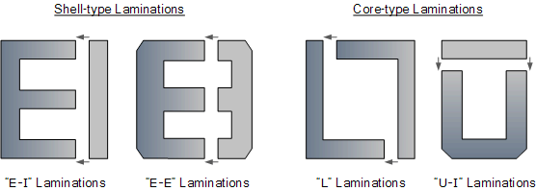

These lamination stampings when connected together form the required core shape. For example, two “E” stampings plus two end closing “I” stampings to give an E-I core forming one element of a standard shell-type transformer core. These individual laminations are tightly butted together during the transformers construction to reduce the reluctance of the air gap at the joints producing a highly saturated magnetic flux density.

Transformer core laminations are usually stacked alternately to each other to produce an overlapping joint with more lamination pairs being added to make up the correct core thickness. This alternate stacking of the laminations also gives the transformer the advantage of reduced flux leakage and iron losses. E-I core laminated transformer construction is mostly used in isolation transformers, step-up and step-down transformers as well as auto transformers.

### II.2.3.Transformer Winding Arrangements

Transformer windings form another important part of a transformer construction, because they are the main current-carrying conductors wound around the laminated sections of the core. In a single-phase two winding transformer, two windings would be present as shown.

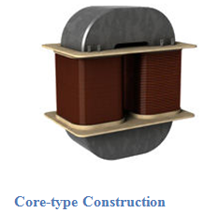

The one which is connected to the voltage source and creates the magnetic flux called the primary winding, and the second winding called the secondary in which a voltage is induced as a result of mutual induction.

If the secondary output voltage is less than that of the primary input voltage the transformer is known as a “Step-down Transformer”. If the secondary output voltage is greater than the primary input voltage it is called a “Step-up Transformer”.

The type of wire used as the main current carrying conductor in a transformer winding is either copper or aluminium. While aluminium wire is lighter and generally less expensive than copper wire, a larger cross sectional area of conductor must be used to carry the same amount of current as with copper so it is used mainly in larger power transformer applications.

Small kVA power and voltage transformers used in low voltage electrical and electronic circuits tend to use copper conductors as these have a higher mechanical strength and smaller conductor size than equivalent aluminium types. The downside is that when complete with their core, these transformers are much heavier.

Transformer windings and coils can be broadly classified into concentric coils and sandwiched coils. In core-type transformer construction, the windings are usually arranged concentrically around the core limb as shown above with the higher voltage primary winding being wound over the lower voltage secondary winding.

Sandwiched or “pancake” coils consist of flat conductors wound in a spiral form and are so named due to the arrangement of conductors into discs. Alternate discs are made to spiral from outside towards the centre in an interleaved arrangement with individual coils being stacked together and separated by insulating materials such as paper of plastic sheet. Sandwich coils and windings are more common with shell type core construction.

Helical Windings also known as screw windings are another very common cylindrical coil arrangement used in low voltage high current transformer applications. The windings are made up of large cross sectional rectangular conductors wound on its side with the insulated strands wound in parallel continuously along the length of the cylinder, with suitable spacers inserted between adjacent turns or discs to minimize circulating currents between the parallel strands. The coil progresses outwards as a helix resembling that of a corkscrew.

The insulation used to prevent the conductors shorting together in a transformer is usually a thin layer of varnish or enamel in air cooled transformers. This thin varnish or enamel paint is painted onto the wire before it is wound around the core.

In larger power and distribution transformers the conductors are insulated from each other using oil impregnated paper or cloth. The whole core and windings is immersed and sealed in a protective tank containing transformer oil. The transformer oil acts as an insulator and also as a coolant.

### II.2.4.Transformer Dot Orientation

We cannot just simply take a laminated core and wrap one of the coil configurations around it. We could but we may find that the secondary voltage and current may be out-of-phase with that of the primary voltage and current. The two coil windings do have a distinct orientation of one with respect to the other. Either coil could be wound around the core clockwise or anticlockwise so to keep track of their relative orientations “dots” are used to identify a given end of each winding.

This method of identifying the orientation or direction of transformers windings is called the “dot convention”. Then transformers windings are wound so that the correct phase relations exist between the winding voltages with the transformers polarity being defined as the relative polarity of the secondary voltage with respect to the primary voltage as shown below.

**Transformer Construction using Dot Orientation**

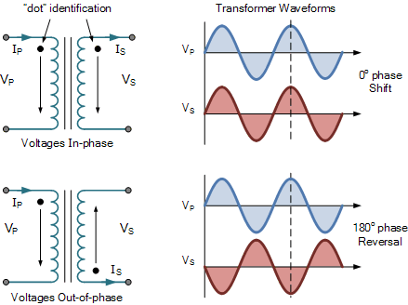

The first transformer shows its two “dots” side by side on the two windings. The current leaving the secondary dot is “in-phase” with the current entering the primary side dot. Thus the polarities of the voltages at the dotted ends are also in-phase so when the voltage is positive at the dotted end of the primary coil, the voltage across the secondary coil is also positive at the dotted end.

The second transformer shows the two dots at opposite ends of the windings which means that the transformers primary and secondary coil windings are wound in opposite directions. The result of this is that the current leaving the secondary dot is 180o “out-of-phase” with the current entering the primary dot. So the polarities of the voltages at the dotted ends are also out-of-phase so when the voltage is positive at the dotted end of the primary coil, the voltage across the corresponding secondary coil will be negative.

Then the construction of a transformer can be such that the secondary voltage may be either “in-phase” or “out-of-phase” with respect to the primary voltage.

### II.2.5.Transformer Core Losses

The ability of iron or steel to carry magnetic flux is much greater than it is in air, and this ability to allow magnetic flux to flow is called **permeability**. Most transformer cores are constructed from low carbon steels which can have permeabilities in the order of 1500 compared with just 1.0 for air.

This means that a steel laminated core can carry a magnetic flux 1500 times better than that of air. However, when a magnetic flux flows in a transformers steel core, two types of losses occur in the steel. One termed “eddy current losses” and the other termed “hysteresis losses”.

**Hysteresis Losses**

Transformer Hysteresis Losses are caused because of the friction of the molecules against the flow of the magnetic lines of force required to magnetize the core, which are constantly changing in value and direction first in one direction and then the other due to the influence of the sinusoidal supply voltage.

This molecular friction causes heat to be developed which represents an energy loss to the transformer. Excessive heat loss can overtime shorten the life of the insulating materials used in the manufacture of the windings and structures. Therefore, cooling of a transformer is important.

Also, transformers are designed to operate at a particular supply frequency. Lowering the frequency of the supply will result in increased hysteresis and higher temperature in the iron core. So reducing the supply frequency from 60 Hertz to 50 Hertz will raise the amount of hysteresis present, decreased the VA capacity of the transformer.

**Eddy Current Losses**

Transformer Eddy Current Losses on the other hand are caused by the flow of circulating currents induced into the steel caused by the flow of the magnetic flux around the core. These circulating currents are generated because to the magnetic flux the core is acting like a single loop of wire. Since the iron core is a good conductor, the eddy currents induced by a solid iron core will be large.

Eddy currents do not contribute anything towards the usefulness of the transformer but instead they oppose the flow of the induced current by acting like a negative force generating resistive heating and power loss within the core.

**Laminating the Iron Core**

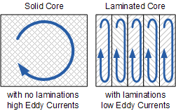

Eddy current losses within a transformer core cannot be eliminated completely, but they can be greatly reduced and controlled by reducing the thickness of the steel core. Instead of having one big solid iron core as the magnetic core material of the transformer or coil, the magnetic path is split up into many thin pressed steel shapes called “laminations”.

The laminations used in a transformer construction are very thin strips of insulated metal joined together to produce a solid but laminated core as we saw above. These laminations are insulated from each other by a coat of varnish or paper to increase the effective resistivity of the core thereby increasing the overall resistance to limit the flow of the eddy currents.

The result of all this insulation is that the unwanted induced eddy current power-loss in the core is greatly reduced, and it is for this reason why the magnetic iron circuit of every transformer and other electro-magnetic machines are all laminated. Using laminations in a transformer construction reduces eddy current losses.

The losses of energy, which appears as heat due both to hysteresis and to eddy currents in the magnetic path, is known commonly as “transformer core losses”. Since these losses occur in all magnetic materials as a result of alternating magnetic fields. Transformer core losses are always present in a transformer whenever the primary is energized, even if no load is connected to the secondary winding. Also these hysteresis and the eddy current losses are sometimes referred to as “transformer iron losses”, as the magnetic flux causing these losses is constant at all loads.

### II.2.6. Copper Losses

There is also another type of energy loss associated with transformers called “copper losses”. Transformer **Copper Losses** are mainly due to the electrical resistance of the primary and secondary windings. Most transformer coils are made from copper wire which has resistance in Ohms, ( Ω ). This resistance opposes the magnetising currents flowing through them.

When a load is connected to the transformers secondary winding, large electrical currents flow in both the primary and the secondary windings, electrical energy and power ( or the I2 R ) losses occur as heat. Generally copper losses vary with the load current, being almost zero at no-load, and at a maximum at full-load when current flow is at maximum.

A transformers VA rating can be increased by better design and transformer construction to reduce these core and copper losses. Transformers with high voltage and current ratings require conductors of large cross-section to help minimize their copper losses. Increasing the rate of heat dissipation (better cooling) by forced air or oil, or by improving the transformers insulation so that it will withstand higher temperatures can also increase a transformers VA rating.

Then we can define an ideal transformer as having:

* No Hysteresis loops or Hysteresis losses  → 0
* Infinite Resistivity of core material giving zero Eddy current losses  → 0
* Zero winding resistance giving zero I2R copper losses  → 0

## II.3.Transformer Loading

In the previous sub-topics, we have assumed that the transformer is ideal, that is one in which there are no core losses or copper losses in the transformers windings.

However, in real world transformers there will always be losses associated with the transformers loading as the transformer is put “on-load”. But what do we mean by: **Transformer Loading**.

Well first let’s look at what happens to a transformer when it is in this “no-load” condition, that is with no electrical load connected to its secondary winding and therefore no secondary current flowing.

A transformer is said to be on “no-load” when its secondary side winding is open circuited, in other words, nothing is attached and the transformer loading is zero. When an AC sinusoidal supply is connected to the primary winding of a transformer, a small current, IOPEN will flow through the primary coil winding due to the presence of the primary supply voltage.

With the secondary circuit open, nothing connected a back EMF along with the primary winding resistance acts to limit the flow of this primary current. Obviously, this no-load primary current ( Io ) must be sufficient to maintain enough magnetic field to produce the required back emf. Consider the circuit below.

**Transformer “No-load” Condition**

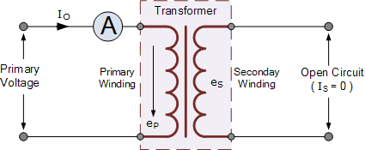

The ammeter above will indicate a small current flowing through the primary winding even though the secondary circuit is open circuited. This no-load primary current is made up of the following two components:

* An in-phase current, IE which supplies the core losses (eddy current and hysteresis).
* A small current, IM at 90o to the voltage which sets up the magnetic flux.

|  |  |
| --- | --- |
| transformer no-load phasor diagram | transformer no-load equation |

Note that this no-load primary current, Io is very small compared to the transformers normal full-load current. Also due to the iron losses present in the core as well as a small amount of copper losses in the primary winding, Io does not lag behind the supply voltage, Vp by exactly 90o, ( cosφ = 0 ), there will be some small phase angle difference.

**Transformer Loading Example No1**

A single phase transformer has an energy component, IE of 2 Amps and a magnetizing component, IM of 5 Amps. Calculate the no-load current, Io and resulting power factor.

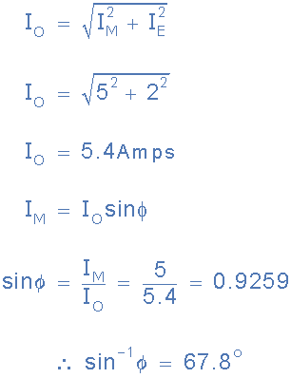

**Transformer “On-load”**

When an electrical load is connected to the secondary winding of a transformer and the transformer loading is therefore greater than zero, a current flows in the secondary winding and out to the load. This secondary current is due to the induced secondary voltage, set up by the magnetic flux created in the core from the primary current.

The secondary current, IS which is determined by the characteristics of the load, creates a self-induced secondary magnetic field, ΦS in the transformer core which flows in the exact opposite direction to the main primary field, ΦP. These two magnetic fields oppose each other resulting in a combined magnetic field of less magnetic strength than the single field produced by the primary winding alone when the secondary circuit was open circuited.

This combined magnetic field reduces the back EMF of the primary winding causing the primary current, IP to increase slightly. The primary current continues to increase until the cores magnetic field is back at its original strength, and for a transformer to operate correctly, a balanced condition must always exist between the primary and secondary magnetic fields. This results in the power to be balanced and the same on both the primary and secondary sides. Consider the circuit below.

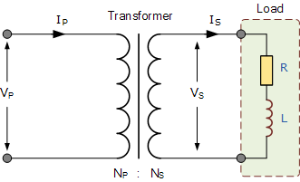

We know that the turns ratio of a transformer states that the total induced voltage in each winding is proportional to the number of turns in that winding and also that the power output and power input of a transformer is equal to the volts times amperes, ( V x I ). Therefore:

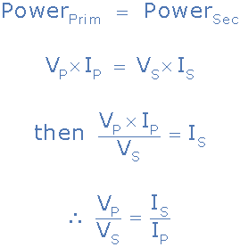

But we also know previously that the voltage ratio of a transformer is equal to the turns ratio of a transformer as: “voltage ratio = turns ratio”. Then the relationship between the voltage, current and number of turns in a transformer can be linked together and is therefore given as:

**Transformer Ratio**

transformer ratio

Where:

* NP/NS = VP/VS  -  represents the voltage ratio
* NP/NS = IS/IP  -  represents the current ratio

Note that the current is inversely proportional to both the voltage and the number of turns. This means that with a transformer loading on the secondary winding, in order to maintain a balanced power level across the transformers windings, if the voltage is stepped up, the current must be stepped down and vice versa. In other words, “higher voltage — lower current” or “lower voltage — higher current”.

As a transformers ratio is the relationships between the number of turns in the primary and secondary, the voltage across each winding, and the current through the windings, we can rearrange the above transformer ratio equation to find the value of any unknown voltage, ( V ) current, ( I ) or number of turns, ( N ) as shown.

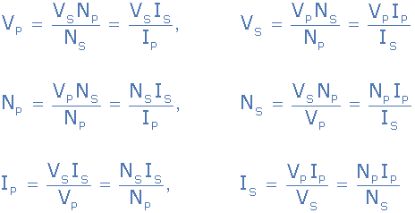

The total current drawn from the supply by the primary winding is the vector sum of the no-load current, Io and the additional supply current, I1 as a result of the secondary transformer loading and which lags behind the supply voltage by an angle of Φ. We can show this relationship as a phasor diagram.

**Transformer Loading Current**

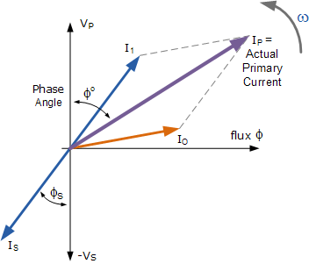

## II.4. Transformer Voltage Regulation

The voltage regulation of a transformer is defined as the change in secondary terminal voltage when the transformer loading is at its maximum, i.e. full-load applied while the primary supply voltage is held constant. Regulation determines the voltage drop (or increase) that occurs inside the transformer as the load voltage becomes too low as a result of the transformers loading being too high which therefore affects its performance and efficiency.

Voltage regulation is expressed as a percentage (or per unit) of the no-load voltage. Then if E represents the no-load secondary voltage and V represents the full-load secondary voltage, the percentage regulation of a transformer is given as:

transformer voltage regulation

So for example, a transformer delivers 100 volts at no-load and the voltage drops to 95 volts at full load, the regulation would be 5%. The value of E – V will depend upon the internal impedance of the winding which includes its resistance, R and more significantly its AC reactance X, the current and the phase angle.

Also voltage regulation generally increases as the power factor of the load becomes more lagging (inductive). Voltage regulation with regards to the transformer loading can be either positive or negative in value that is with the no-load voltage as reference, the change down in regulation as the load is applied, or with the full-load as reference and the change up in regulation as the load is reduced or removed.

In general, the regulation of the core type transformer when the transformer loading is high is not as good as the shell type transformer. This is because the shell type transformer has better flux distribution due to the interlacing of the coil windings.

**END!!!**